**Bootstrapping (30th August 2024)**

1. Create a EC2 instance with stuffing and installing some package

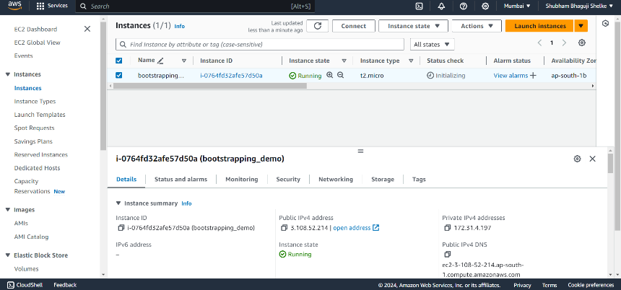

1. Connected the BootStarapping-VM01 via putty

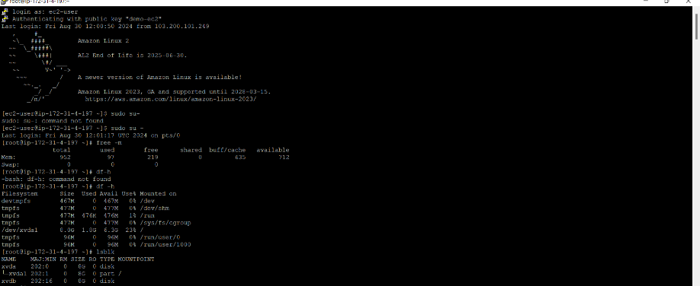

1. Check the memory

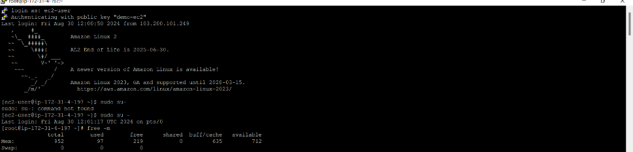

1. Check whether the package of httpd & telnet installed or not?

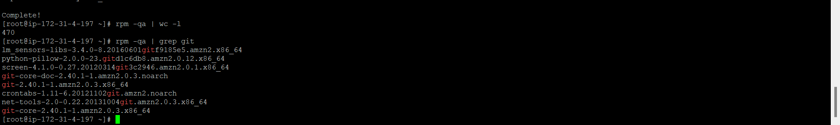

1. Check the total number of packages installed on the system

